SubSystem title

# ERD for UX process

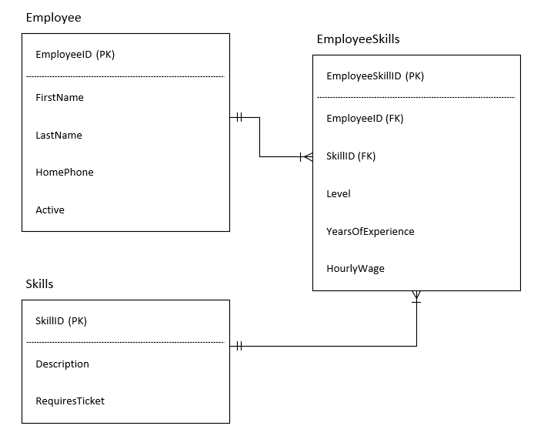

# Possible UX Interface

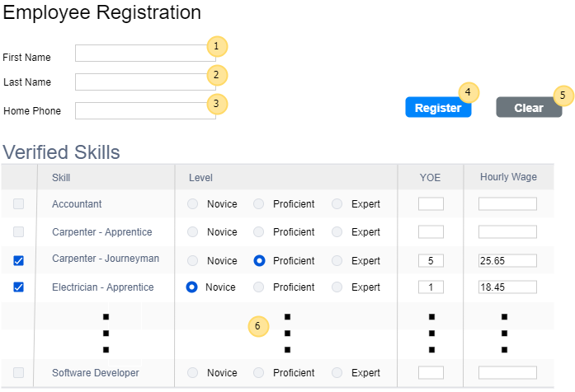

|  |  |  |
| --- | --- | --- |
| **Controls** | | **Events** |
| SkillsList (**6**) | | Page Load   * Load the ListView Skill column with the distinct skills via the List_AllSkills method in SkillController * All other fields are simply populated on the page with the appropriate input element |
| **BLL Class(es) and Method (s)** | | |
| SkillController | List<SkillItem> List_AllSkills()   * Retrieve a list of all distinct skill descriptions | |
| **SQL Table(s): (C,R,U,D)** | | **ViewModel** |
| R | | SkillItem, SelectionList |

# Event and Wiring Summations

|  |  |  |
| --- | --- | --- |
| **Controls** | | **Events** |
| Clear (**5**) , FirstName (**1**), LastName (**2**), HomePhone (**3**) | | Clear OnClick   * Sets FirstName input value to an empty string * Sets LastName input value to an empty string * Sets HomePhone input value to an empty string * Clears all the checkboxes in the SkillsList ListView * Clears all the radio buttons in the SkillsList ListView * Clears all the YOE text inputs in the SkillsList ListView * Clears all the HourlyWage text inputs in the SkillsList ListView |
| **BLL Class(es) and Method (s)** | | |
| None | None | |
| **SQL Table(s): (C,R,U,D)** | | **ViewModel** |
| None | | None |

|  |  |  |
| --- | --- | --- |
| **Controls** | | **Events** |
| Register (**4**), FirstName (**1**), LastName (**2**), HomePhone (**3**) | | Register OnClick   * Validate FirstName value as valid string * Validate LastName value as valid string * Validate HomePhone value as valid double and use RegEx validation for correct pattern * Ensure there is at least one Skill for the employee that is checked * Ensure any checked Skills in the SkillsList ListView have a skill selected, YOE value, and Hourly Wage value * Validate YOE as a valid integer between 0 and 100 inclusive * Validate Hourly Wage as a valid double between 15.00 and 100.00 inclusive |
| **BLL Class(es) and Method (s)** | | |
| EmployeeController  EmployeeSkillController | int Employee_Add(EmployeeItem item)   * Add new Employee using values from the FirstName, LastName, and HomePhone text fields * Active will be inserted as a True value.   int EmployeeSkill_Add(EmployeeSkillItem item)   * Add checked employee skills with the employee ID that was returned in the Employee_Add method * The skill ID will be grabbed from the SkillsList ListView for any checked row * The radio button list will ensure the skill level is inserted as a value between 1 – 3 inclusive * The YearsOfExperience and HourlyWage values will be attained from the YOE and Hourly Wage text inputs. | |
| **SQL Table(s): (C,R,U,D)** | | **ViewModel** |
| C | | EmployeeItem, EmployeeSkillItem |